# Computer Networking hw1

Student ID:2016302580032 name:杨博东

1. ping another conputer

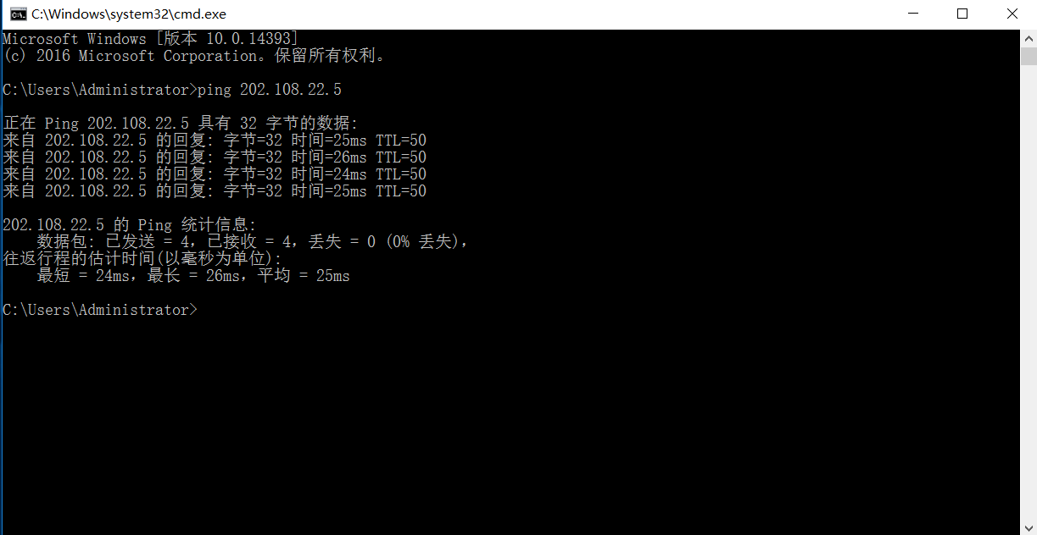

1. tracert a server 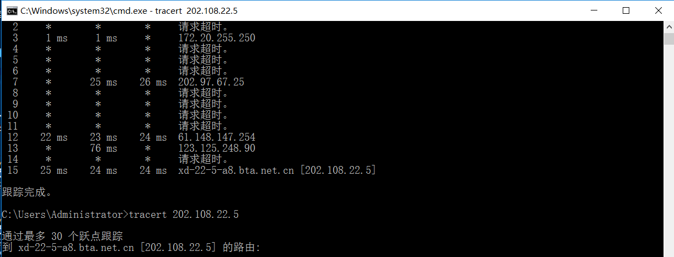
2. three after-class exercise

